Story: Nginx docker container with load balancing.
Step-1: Install docker and nginx in your machine

Step-2: Make nginx.conf file where need to mention all the ports where the application running along with the IP. Mention ip with port and listen port also by following below procedure:
http {
upstream myapp1 {
server 192.168.1.9:8080;
server 192.168.1.9:8081;
}

server {
listen 80;

location / {
proxy_pass http://myapp1;
}
}
}
events {}
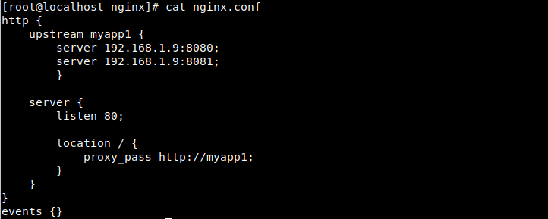
Step-3: run the below command to check the validation of “nginx.conf”
sudo nginx -t
Step4: Now, create a docker-compose file for creating two nginx web server. Write the below lines in docker-compose.yml:
version: '3.9'
services:
#Nginx Service
test:
image: nginx:latest
container_name: test
ports:
- 8080:80
nginx1:
image: nginx:latest
container_name: nginx1
ports:
- 8081:80
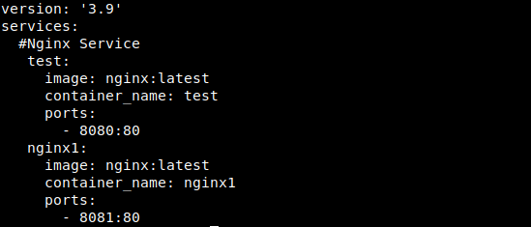

Step-5: Now run the docker-compose file by the following command:
docker-compose up -d
Step-6: Check container running or not by the following command:
docker ps

Result:
Now if you hit “192.168.1.9:80” first time it twill access the 192.168.1.9:8080 web server and if you reload again the browser or hit again in “192.168.1.9:80” it will access the 192.168.1.9:8081 web server
